**AIR JORDAN 1 CHICAGO “LOST AND FOUND”. Why is it still relevant in 2022?**

*Exploring the legacy and the cult of the Air Jordan OG Chicago and why it still makes our jaw drop in 2022: A Sneakerhead's Perspective*

Are you bored of the current line of sneakers that are either too loud or too basic for your taste? Are you looking for a pair with an iconic design, dashing personality, oozing confidence, and a grand legacy behind it? Then you are in the right time in history as Nike has dropped what undeniably is the holy grail of sneakers – Air Jordan 1 “Chicago” Lost and Found.

Designed by the late great Peter Moore, the Air Jordan 1 Chicago burst into the streets in 1985, after Michael Jordan made its debut on court in the previous basketball season in late 1984. The silhouette was the first of its kind to be designed and challenged the status quo with its bold look of high ankle length and unique color scheme with blocks of red and white – something that was new and wild at the time and is a head turner even today. With Michael Jordan’s 1 rapid success on court, the demand for Air Jordan 1s went through the roof such that retailers had to rethink strategies for managing their inventories to stock more pairs. Air Jordan 1’s success didn’t just mark the beginning of a new era of sneaker collection but also announced Nike as a top global brand of sneakers with the “Shoe Dog” company making a whooping [$130 million sales](https://www.businessinsider.in/retail/news/how-nikes-air-jordan-1-became-and-remained-the-most-prized-lifestyle-sneaker/articleshow/95624280.cms) in 1985 just from Jordan products alone.

Over the following four decades Air Jordan collection has launched over 30 silhouettes making waves each time, globally. However, some things are born to rule till time eternal and the crown of elite sneakers kingdom still rests on the OG Air Jordan 1 “Chicago”.

But almost 40 years down the line is it still a competition to the current modern line of sneakers?

Read below to find out the only **FOUR** reasons you need to know why this pair is still a headliner in 2022:

* A long-lasting legacy … albeit with a controversial beginning
* A classic design that can be flexed comfortably with style!
* Nostalgia – An ode to a different time
* Resale value

1. A long-lasting legacy … albeit with a controversial beginning

Sneaker industry can be competitive and only few designs even last a decade let transcend across three. When [Peter Moore](https://en.wikipedia.org/wiki/Peter_Moore_(shoe_designer)) and Nike designed and launched the very first pair of Air Jordan 1s through the then rising basketball star [Michael Jordan](https://en.wikipedia.org/wiki/Michael_Jordan), little did they imagine the kind of impact it would have on the way people viewed their sneakers. They certainly could not have predicted or expected their brainchild survive through the test of time. But it didn’t just survive, the silhouette thrived.

As Michael Jordan slam dunked and shattered records every season, so did Air Jordan’s popularity and sales. Ever since its inception, every new generation want to be having a pair of this timeless silhouette, almost with a sense of “discovery”. In the past five years alone, the Jordan brand has brought in [$19 billion](https://thesportsrush.com/nba-news-earning-merely-5-from-jordan-brand-michael-jordan-has-brought-in-19-billion-for-nike-in-5-year/) for Nike.

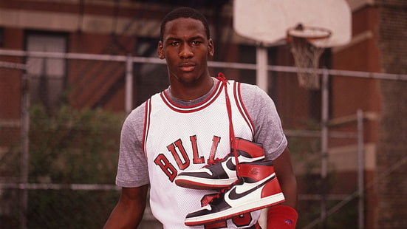

What makes this enduring legacy even more interesting is that the journey had a rocky start. Like any other fairy tale story that challenged the status quo, Air Jordan 1s story was no different. The AJ1 was banned by the NBA executives for not meeting the league’s uniform and color guidelines and Michael Jordan was ordered not to play in those shoes unless he was ready to pay a hefty $5000 per every game he played in AJ. But rules are man-made and are meant to be challenged for more inclusivity. MJ continued to slay every game wearing his namesake shoes, with Nike happily paying the fine for him. Any publicity was good publicity and the controversy around the shoe was a blessing in disguise for the brand as it attracted a lot of attention off the court. This and a brilliant marketing campaign that exploited the “drama” by NBA, was enough to create a hysteria which soon turned into queues on the streets and started a domino effect that changed the sneaker industry forever, ushering in a new era where collecting sneakers would become a fad and copping a pair of retro Jordans would be a Eureka moment.

1. A classic design that can be flexed comfortably with style!

The Air Jordan 1 design has aged like fine wine, growing in stature with every passing decade. The original AJ1 “Chicago” silhouette was launched in red and white colorway with bigger swoosh on the sides and a celebrated logo of a basketball with outstretched wings at the top of the ankle, making it an overall strong, confident, and eye-catching look. Even after close to four decades since its original release the iconic silhouette is so universal that even a casual sneaker enthusiast would be able to spot the design and colorway from a distance.

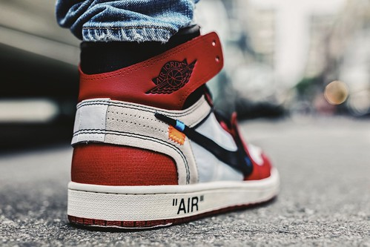

Originally produced for playing basketball, but the newly reimagined pairs offer more flexibility and style to flaunt and function both on and off the court. The leather overlays offer upper stability and durability while the leather toe box is breathable for additional ventilation. The circular pattern and advanced rubber sole allows firm grip and quick, free, and comfortable movement without hurting your feet. The Chicago colorway of red and white couple with its bold design makes it an impressive option to complete any look and style for any occasion.

1. Nostalgia – An ode to a different time

Lost and Found box


The initial frenzy around the then newly launched Air Jordan 1 Chicago in 1985 sent retailers to their drawing boards to devise new strategies to tackle the surge in demands. New inventories were set up and fully stocked up with the AJ1s as stores expected demand to never cease. But soon after, the demand saturated, and lot of these pairs were lost as deadstock. As Nike belted out newer versions of AJ1s over the next three decades, the OG colorway seemed “lost” but never completely out as people continued to seek and find this coveted colorway every now and then. So with such an aesthetic value and undying demand it only made sense for Nike to relaunch this colorway, reimagined as Nike Air Jordan 1 OG High “Chicago” “Lost and Found”.

This shoe fondly reflects on a bygone era when collecting sneakers was not done easily through few clicks on the internet but required a lot of passion and enthusiasm to carry out meticulous research, create network of trusted sources and a lot of travel only to cop that favorite pair lying lost at the back of some store inventory.

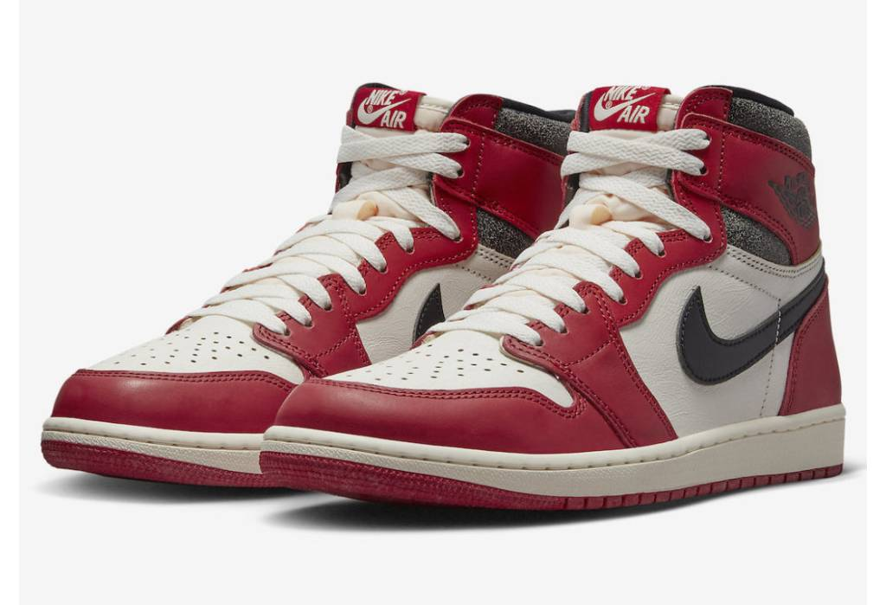

The “Lost and Found” theme is evident from the cracked leather and the weather shoebox with small store type wrapping paper.

This release is a homage to the sentimental value and love that people across generations have carried for this pair and its also a statement that this colorway may come and go but will never be “lost” and will always find a way back to people’s hearts ( and feet of course).

1. Resale value

Enough with our emotional attachment to sneakers, now let’s look at things practically. Collecting sneakers is not just a passion or a hobby but also an art which requires a lot of patience, dedication, and efforts; and, what’s better than a regular art is an art that can make serious money.

In the recent times, sneakers have become a lucrative side hustle for many people around the globe. Sneakerheads would go the distance to cop elusive pairs of sneakers not just to grow their own collection but to re-sell in future and generate profits. Profits can run anything between couple of thousands to millions of dollars. According to a study of [Cowen Equity Research](https://sports.yahoo.com/global-sneaker-resale-market-could-reach-30-billion-by-2030-cowen-191003371.html) , the sneaker resale market could be worth $30 billion by 2030. The resale value of AJs is 1,816%, way higher than any other sneaker line in current times.

Now, Air Jordans are not cheap, even the most readily available and accessible ones being priced at hundreds of dollars and running up to thousands for the limited editions and celebrity collab models. Because Air Jordan 1 Chicago OG High “Lost and Found” colorway has always attracted sizeable attention, Nike has resorted to limited release of the style to keep it’s rare and coveted status alive. This only increases their demand and spikes up their resale value as people have an inherent urge to stay exclusive.

The Air Jordan 1 Chicago “Lost and Found” colorway will always hold a sentimental value and if you can get your hands on a pair then it can be used as an investment opportunity to make sizeable profits in the resale market.

Air Jordan 1 Chicago OG High “Lost and Found” pays homage to an athlete, a city and its people who rewrote the perception of sneakers and collectively gave birth to an epic partnership that became synonymous with vision, style and success globally .It’s more than just an ordinary shoe , it’s a crown – a crown for everyone who aspires to break the glass ceiling and make their mark in this world. The classic design, retro appeal, rich history of association with Michael Jordan’s meteoric rise, and limited availability make it a gold standard in the sneaker-verse and a must have for even the most casual sneaker or fashion enthusiast.